Subject: Reminder to Identify Hazardous Materials on the DIBBS Quote

A Material Safety Data Sheet and product labeling are required for hazardous materials delivered to the Government. At the “Hazardous Material Identification and Material Safety Data” section of the DIBBS quote, the Contractor must state whether the offer includes Hazardous Material, as defined in FAR 52.223-3, by selecting “NO” or “YES”. If “Yes,” FAR 52.223-3 and DFARS 252.223-7001 are applicable to the contract/order.
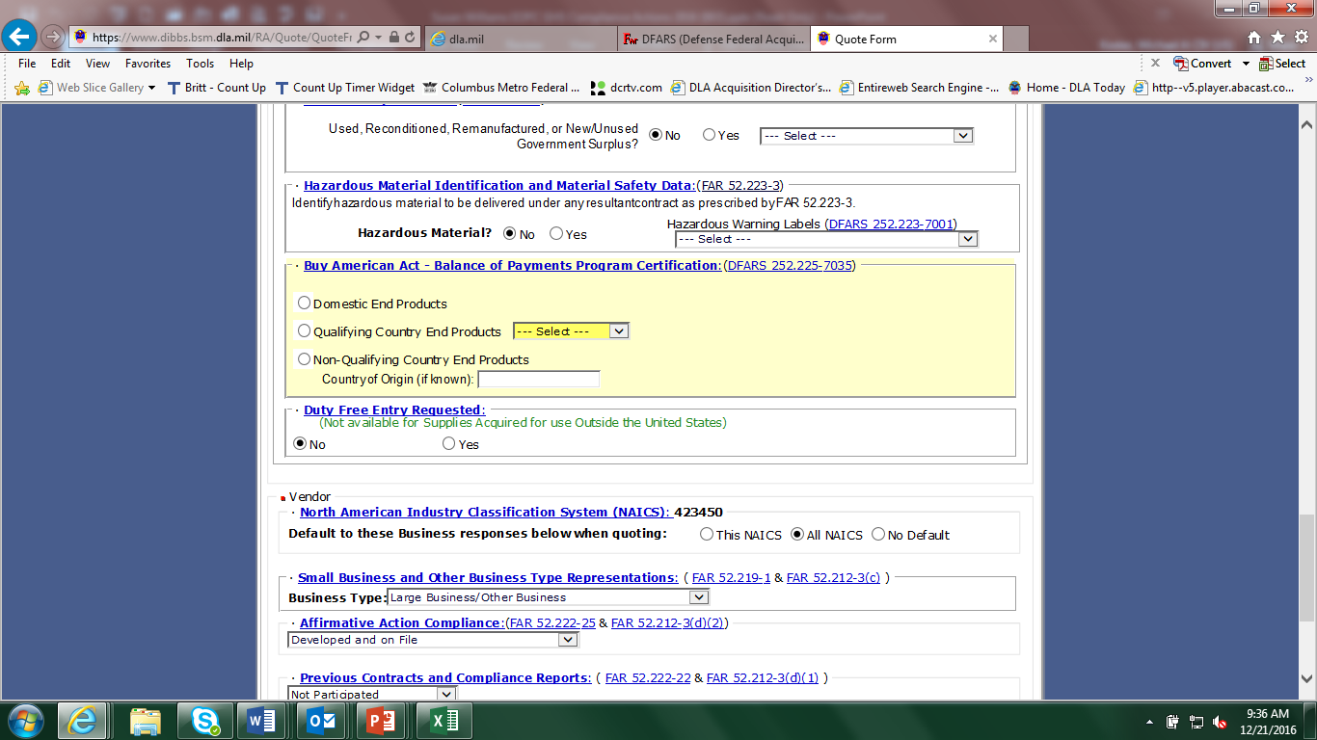

If hazardous material is being offered, the Contractor shall indicate rather the Hazardous Warning Labels will be in accordance with the Hazard Communication Standard (29 CFR 1910.1200 et seq), or one of the following statutes:
Federal Insecticide, Fungicide and Rodenticide Act;
Federal Food, Drug and Cosmetics Act;
Consumer Product Safety Act;
Federal Hazardous Substances Act; or
Federal Alcohol Administration Act.

